Eskom Kimberley Strengthening Phase 4 Project

Application 2: Boundary - Ulco
(DEA Reference – DEA Reference – 14/12/16/3/3/2/646)

Final Specialist Report for the Environmental Impact Phase

Bird Impact Assessment Report
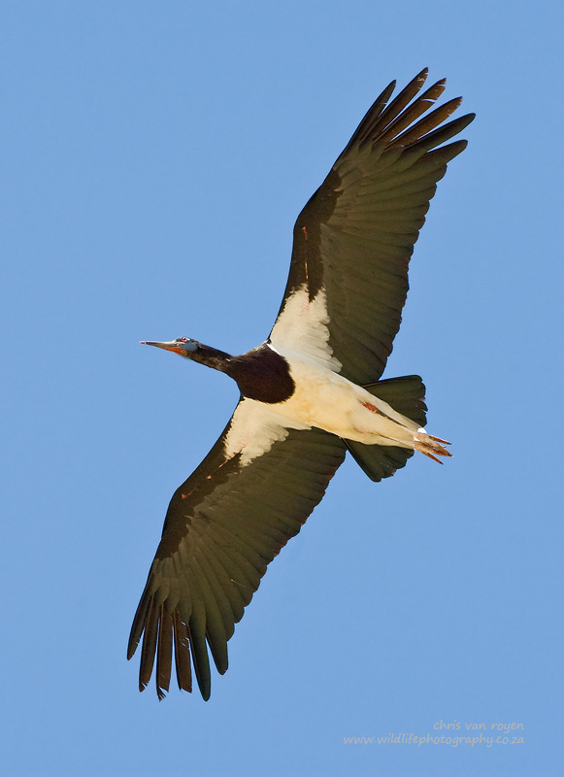

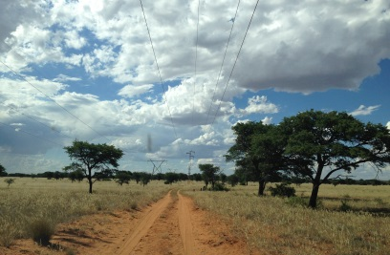

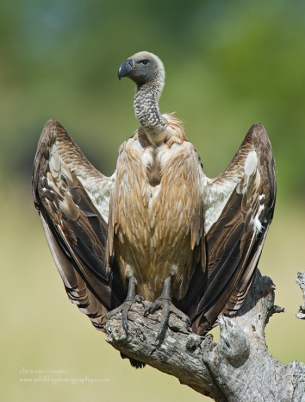

FEBRUARY 2015

Chris van Rooyen
Albert Froneman

Chris van Rooyen
Chris has seventeen years’ experience in the management of wildlife interactions with electricity infrastructure. He was head of the Eskom-Endangered Wildlife Trust (EWT) Strategic Partnership from 1996 to 2007, which has received international acclaim as a model of co-operative management between industry and natural resource conservation. He is an acknowledged global expert in this field and has worked in South Africa, Namibia, Botswana, Lesotho, New Zealand, Texas, New Mexico and Florida. Chris also has extensive project management experience and has received several management awards from Eskom for his work in the Eskom-EWT Strategic Partnership. He is the author of 15 academic papers (some with co-authors), co-author of two book chapters and several research reports. He has been involved as ornithological consultant in more than 100 power line and 25 wind generation projects. Chris is also co-author of the Best Practice for Avian Monitoring and Impact Mitigation at Wind Development Sites in Southern Africa, which is currently (2013) accepted as the industry standard. Chris also works outside the electricity industry and had done a wide range of bird impact assessment studies associated with various residential and industrial developments.

Albert Froneman (Pr.Sci.Nat)
Albert has an M. Sc. in Conservation Biology from the University of Cape Town, and started his career in the natural sciences as a Geographic Information Systems (GIS) specialist at Council for Scientific and Industrial Research (CSIR). He is a registered Professional Natural Scientist in the field of zoological science with the South African Council of Natural Scientific Professionals (SACNASP). In 1998, he joined the Endangered Wildlife Trust where he headed up the Airports Company South Africa – EWT Strategic Partnership, a position he held until he resigned in 2008 to work as a private ornithological consultant. Albert’s specialist field is the management of wildlife, especially bird related hazards at airports. His expertise is recognized internationally; in 2005 he was elected as Vice Chairman of the International Bird Strike Committee. Since 2010, Albert has worked closely with Chris van Rooyen in developing a protocol for pre-construction monitoring at wind energy facilities, and they are currently jointly coordinating pre-construction monitoring programmes at several wind farm facilities. Albert also works outside the electricity industry and had done a wide range of bird impact assessment studies associated with various residential and industrial developments.

DECLARATION OF INDEPENDENCE
I, Chris van Rooyen as duly authorised representative of Chris van Rooyen Consulting, and working under the supervision of and in association with Albert Froneman (SACNASP Zoological Science Registration number 400177/09) as stipulated by the Natural Scientific Professions Act 27 of 2003, hereby confirm my independence (as well as that of Chris van Rooyen Consulting) as a specialist and declare that neither I nor Chris van Rooyen Consulting have any interest, be it business, financial, personal or other, in any proposed activity, application or appeal in respect of which Landscape Dynamics Environmental Consulting was appointed as environmental assessment practitioner in terms of the National Environmental Management Act, 1998 (Act No. 107 of 1998), other than fair remuneration for worked performed, specifically in connection with the Environmental Impact Assessment for the proposed Boundary to Ulco transmission line.
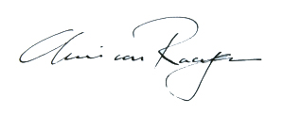
___________________________
Full Name: Chris van Rooyen
Title / Position: Director

EXECUTIVE SUMMARY

BACKGROUND
ESKOM has appointed Landscape Dynamics Environmental Consultants to undertake an Environmental Impact Assessment (EIA) for the proposed Kimberley Strengthening Phase 4 Project. The total project entails the construction of an approximate 390km double circuit 400kV powerline. The line starts west of the town of Dealesville in the Free State and ends south of Kathu in the Northern Cape. The approximately 390km powerline runs east to west, starting at the Beta Substation, connects to the Boundary Substation, then on to the Ulco Substation, connects at the Olien Substation, then Manganore Substation and ends at the Ferrum Substation.

The project will be handled in four different applications:

- Application 1: Beta to Boundary (DEA Reference – 14/12/16/3/3/2/647)
- Application 2: Boundary to Ulco (DEA Reference – 14/12/16/3/3/2/646
- Application 3: Ulco na Olien na Manganore (DEA Reference – 14/12/16/3/3/2/645)
- Application 4: Manganore to Ferrum (DEA Reference – 14/12/16/3/3/2/644)

Landscape Dynamics Environmental Consultants has appointed Chris van Rooyen Consulting as specialist to investigate the potential bird related impacts associated with the proposed new transmission lines. This assessment report deals with Application 2 i.e. the construction of an approximately 94km double circuit 400kV powerline from the existing Boundary TX (Transmission) Substation to the Ulco Substation, including a new Ulco TX (Transmission) Substation adjacent to the existing Ulco DX (Distribution) Substation. The Boundary Substation and a short section of the line are situated in the Tokologo Local Municipality in the Free State Province. The line runs in a westerly direction and then enters the Northern Cape Province north of Kimberley. It runs through the areas of the Sol Plaatjies and the Dikgatlong Local Municipalities and ends at the small mining town of Ulco.

POTENTIAL IMPACTS

Electrocutions
Due to the large size of the clearances on overhead lines of 400kV, electrocutions are ruled out as even the largest birds cannot physically bridge the gap between energised and/or energised and earthed components. The risk of electrocution posed to Red Data species by the new power line infrastructure is likely to be negligible.

Collisions
The most likely potential candidates for collision mortality on the proposed power line are Kori Bustard, Greater Flamingo, Lesser Flamingo, Secretarybird, Abdim’s Stork, White-backed Vulture, Yellow-billed Stork, Black Stork, Verreaux’s Eagle and Cape Vulture. Ludwig’s Bustard will also be at risk, based on the species flight characteristics and tendency to fly long distances between foraging and roosting areas and when migrating. Movements by this species are triggered by rainfall (Allan 1994), and so are inherently erratic and unpredictable in this arid environment, where the quantity and timing of rains are highly variable between years. However, the proposed corridors are both situated in the savanna biome, which is not the ideal habitat for the species - it was only reported in two quarter degree grid cells, with a maximum reporting rate of 2%. The highest risk for Ludwig’s Bustard is likely to be on irrigated fields and dry pans. Flamingos might be at risk near water bodies, particularly large pans. Kori Bustards might be at risk anywhere in the savanna habitat, particularly when flying to roost sites in the late afternoon and early evening. Secretarybirds will be most at risk in areas of open woodland with a prominent grass layer, and when descending to pans to drink. Abdim’s Stork will be at risk at pans, where they often roost in large numbers, and in irrigated areas, where they forage in large numbers. White-backed Vultures are at risk in breeding colonies, particularly in Dronfield Farm and Rivermead colonies. Cape Vultures are at risk in areas where they roost on transmission towers. Black Stork and Yellow-billed Stork will be at risk at river crossings and pans. Black Stork, Lanner Falcon and Verreaux’s Eagle might be at risk where the proposed lines cross the low cliffs at the edge of the Ghaap Plateau. Tawny Eagle, Martial Eagle and Lappet-faced Vulture might be at risk anywhere in savanna habitat, but particularly when descending to and leaving from pans when visiting to drink and bath. Burchell’s Courser, Double-banded Courser, Chestnut-banded Plover, Caspian Tern and Greer Painted-snipe are also potentially at risk of collisions, but less so than the larger species as they are more agile and therefore less likely to collide with the earthwires of the proposed lines.

Displacement due to habitat destruction and disturbance
In the present instance, the risk of displacement of Red Data species due to habitat destruction is likely to be fairly limited, given the nature of the habitat. The one exception to the last statement is the White-backed Vulture breeding colonies, where the removal of large Camel Thorn trees could result in the destruction of nests, and the resultant displacement of breeding birds. As mentioned earlier, Alternative One Route Corridor bisects the small Rivermead colony (11 nests and 5 active pairs) which is of fairly minor importance compared to the large and very active Dronfield colony (89 nests and 65 active pairs). Both the route corridor alternatives are routed south of the Dronfield breeding areas and should therefore not impact directly on the breeding activity.

Apart from direct habitat destruction, the above mentioned construction and maintenance activities could also potentially impact on birds through disturbance, particularly at the aforementioned White-backed Vulture breeding colonies. This could lead to breeding failure if the disturbance happens during a critical part of the breeding cycle. Construction activities in close proximity could be a source of disturbance and could lead to temporary breeding failure or even permanent abandonment of nests. However, as mentioned earlier, the important Dronfield colony is not affected by any of the two corridors, and the potential impact on the Rivermead colony is fairly limited on a regional scale due to limited significance of the colony from a regional perspective.

SELECTION OF A PREFERRED ALTERNATIVE

All the route alternative corridors emerged with very similar risk ratings, with only a 10% difference in ratings between the highest risk (Alternative Two Route Corridor) and the lowest risk (Alternative One A Route Corridor). This indicates that all the various route alternative corridors are very similar as far as envisaged impacts on avifauna are concerned. The main reason for Alternative One/A Route Corridor emerging with a slightly lower risk rating than Alternative Two Route Corridor is the fact that the latter is 17% longer than the former. However, the scoring system does not account for risk factors lying beyond the boundaries of the 2km corridor. In the case of avifauna, it may on occasion be necessary to consider factors beyond the 2km corridor to better assess the collision risk that a new line poses. In this instance, a section of Alternative One/A Route Corridor is located between two areas of agriculture along the Harts River which is located largely beyond the 2km corridor boundaries, which most likely acts as a focal point for collision sensitive species such as Ludwig’s Bustard and Abdim’s Stork. It is highly likely that there is regular traffic of these species and other non-Red Data species of avifauna between these two agricultural areas, which would expose them to a collision risk. If this is taken into account, the scales tilt towards Alternative Two Route Corridor as the preferred option, despite it being a longer route. In addition, Alternative One/A Route Corridor cuts through the Rivermead vulture colony, which, although a minor colony, is not a desirable outcome. Alternative Two Route Corridor is therefore put forward as the recommended alternative from an avifaunal impact assessment perspective.

RECOMMENDATIONS

It is not the objective of this report to attempt to demarcate all sections of power line for all the alternative corridors that would need to be mitigated for potential collisions or disturbance of Red Data breeding species. This can only be done once the final alignments have been selected and tower positions have been finalized. At this stage, the following recommendations are put forward from a potential bird impact perspective:

- For the reasons stated above, Alternative Two Route Corridor is assessed to be the alternative with the lowest risk to birds. It is therefore recommended that this alternative is used.
- If however Alternative One/A Route Corridor is selected, prior to construction commencing, an inspection should be conducted in the area where the corridor bisects the Rivermead vulture breeding area in order for the avifaunal specialist to record any White-backed Vulture nests that could be impacted by the construction of the proposed line. Should any nests be recorded, it would require management of the potential impacts on the breeding birds once construction commences, which would necessitate the involvement of the avifaunal specialist, and the Environmental Control Officer. An effective communication strategy should be implemented whereby an avifaunal specialist is provided with a construction schedule which will enable them to ascertain when and where breeding vultures could be impacted by the construction activities. This could then be addressed through the timing of construction activities during critical periods of the breeding cycle, once it has been established that a particular nest is active.
- Once the final alignments and tower positions have been selected, the sections of the line that would need the application of Bird Flight Diverters to mitigate for potential collisions should be indicated by the avifaunal specialist by means of a “walk-through” exercise. This exercise should be informed by an analysis of satellite imagery supplemented by on site ground-truthing (physical inspection). The type of Bird Flight Diverter to be used and the marking scheme will be determined during that phase of the project.
- The Eskom standard procedure with regard to the clearing of vegetation must be strictly adhered to, to minimise the extent of habitat destruction and disturbance during the construction phase. Existing roads should be used as far as possible to prevent further habitat fragmentation through the construction of new access roads, and to limit the construction footprint.

------------------------------------------------------

Introduction

ESKOM has appointed Landscape Dynamics Environmental Consultants to undertake an Environmental Impact Assessment (EIA) for the proposed Kimberley Strengthening Phase 4 Project. The total project entails the construction of an approximate 390km double circuit 400kV power line. The line starts west of the town of Dealesville in the Free State and ends south of Kathu in the Northern Cape. The approximately 390km powerline runs east to west, starting at the Beta Substation, connects to the Boundary Substation, then on to the Ulco Substation, connects at the Olien Substation, then Manganore Substation and ends at the Ferrum Substation.

The project will be handled in four different applications:

- Application 1: Beta to Boundary (DEA Reference – 14/12/16/3/3/2/647)
- Application 2: Boundary to Ulco (DEA Reference – 14/12/16/3/3/2/646
- Application 3: Ulco na Olien na Manganore (DEA Reference – 14/12/16/3/3/2/645)
- Application 4: Manganore to Ferrum (DEA Reference – 14/12/16/3/3/2/644)

Landscape Dynamics Environmental Consultants has appointed Chris van Rooyen Consulting as specialist to investigate the potential bird related impacts associated with the proposed new transmission lines. This assessment report deals with Application 2 i.e. the construction of an approximately 94km double circuit 400kV power line from the existing Boundary TX (Transmission) Substation to the Ulco Substation, including a new Ulco TX (Transmission) Substation adjacent to the existing Ulco DX (Distribution) Substation. The Boundary Substation and a short section of the line are situated in the Tokologo Local Municipality in the Free State Province. The line runs in a westerly direction and then enters the Northern Cape Province north of Kimberley. It runs through the areas of the Sol Plaatjies and the Dikgatlong Local Municipalities and ends at the small mining town of Ulco.

See Figure 1 for a map of the various Boundary to Ulco corridor alternatives.

Background and brief

The terms of reference for this impact assessment study are as follows:

- Describe the affected environment;
- Indicate how birdlife will be affected;
- Discuss gaps in baseline data;
- Evaluate the expected impacts;
- Indicate a preferred corridor; and
- Provide recommendations for mitigation.

Study Approach

3.1 Sources of information

The study made use of the following data sources:
- Bird distribution data of the Southern African Bird Atlas Project2 (SABAP2) was obtained (http://sabap2.adu.org.za/), in order to ascertain which species occur in the study area. A separate data set was obtained for each quarter degree grid cell (QDGC) which overlapped with the proposed corridors. QDGCs are grid cells that cover 15 minutes of latitude by 15 minutes of longitude (15. × 15.), which correspond to the area shown on a 1:50 000 map. The SABAP2 data covers the period 2007 to present. The QDGCs are 2824DB, 2824DA, 2824BC, 2824CB, 2824AD, 2824AC.
- The Important Bird Areas (IBA) project data was consulted to get an overview of important bird areas and species diversity in the study area (Barnes 1998; BLSA 2014).
- The power line bird mortality incident database of the Endangered Wildlife Trust (1996 to 2007) was consulted to determine which of the species occurring in the study area are typically impacted upon by power lines (Jenkins et al. 2010).
- Land cover data for the study area was obtained from the National land Cover Project (NLCP) (updated version 2009), obtained from the South African National Biodiversity Institute.
- Data on biomes and vegetation types in the study area was obtained from the Vegetation Map of South Africa, (Mucina & Rutherford 2006) and Vegetation of South Africa, Lesotho and Swaziland (Low & Rebelo 1996).
- The conservation status of all species considered likely to occur in the area was determined as per the most recent iteration of the South African Red Data list for birds (Taylor 2014), and the most recent and comprehensive summary of southern African bird biology (Hockey et al. 2005).
- Personal observations have also been used to supplement the data that is available from SABAP2, and has been used extensively in forming a professional opinion of likely bird/habitat associations.
- Information on the size and location of vulture colonies around Kimberley and in the north-western Free State was obtained from Campbell Murn, (editor of Vulture News, The Journal of the IUCN Vulture Specialist Group), Beryl Wilson (Head of the Zoology Department, McGregor Museum) and Brian Colahan (Ornithologist, Free State Department of Economic Development, Tourism & Environmental Affairs).
- Onsite inspections in a vehicle and on foot, and a helicopter fly-over, were conducted during February 2014 to gain a general impression of bird habitats.
- Satellite data from Google Earth was used to demarcate certain bird habitat classes i.e. ridges, agriculture, urban areas and some pans.
- Information on the locality of existing Eskom HV lines was obtained from Eskom.
- Information on the locality of pans was sourced from the SANBI Wetland Freshwater Priority Areas (FEPAs) database, supplemented with Google Earth imagery.

3.2 Limitations & assumptions

This study made the assumption that the above sources of information are reliable. However, the following factors may potentially detract from the accuracy of the predicted results:

- Although the NLCP data was updated in 2009, the land cover situation on the ground may have changed in places since then. It is however unlikely that any major changes have taken place in the study area.
- Different levels of survey effort for pentads in the SABAP2 coverage means that the reporting rates of species may not be an accurate reflection of relative densities in the pentads that were sparsely covered to date, and which makes up the relevant QDGCs (one QDGC encompasses 9 pentads). The reporting rates were therefore not treated as an absolute measurement of the actual densities, but as an estimate for the potential presence of a specific species. Strong reliance was placed on professional judgment (see 3.1 above).
- Predictions in this study are based on experience of these and similar species in different parts of South Africa. Bird behaviour can never be entirely reduced to formulas that will hold true under all circumstances; therefore professional judgment played an important role in this assessment. It should also be noted that the impact of power lines on birds has been well researched with a robust body of published research stretching over thirty years.

Study area

4.1 Important Bird Areas

The study area extends for approximately 90km from the Boundary Substation near Kimberley to the Ulco substation approximately 13km northwest of Delportshoop. There are two alternative corridors. Investigations are focused on a 2km wide corridor with the proposed alignment as the centre line (see Figure 1 below). Three IBAs are located within 11km from the Boundary substation. The three IBAs are the following:
- Benfontein (SA 033);
- Dronfield Farm (SA 031); and
- Kamfers Dam (SA 032)

Dronfield Farm lies 5km north of Kimberley on the road to Warrenton. The farm holds large numbers of breeding White-backed Vulture, the latest count indicates 89 nests of which 65 were active in 2014. The property also contains breeding Martial Eagle and various other non-threatened raptor species (Wilson 2014). This farm was privately owned by De Beers Consolidated Mines Limited (DBCM) and used purely for cattle farming from the 1920s to 1960s. Thereafter Springbok were introduced, and later Hartebeest, Eland, Gemsbok, Blue and Black Wildebeest, Zebra, Impala and Blesbok, and the land was used for game and cattle farming until 2004. In 2005 it became a game farm. A vulture restaurant on the property provides supplementary food for the vultures. In 2012 the sale of DBCM to Anglo American was concluded (Barnes 1998; BLSA 2014).

Benfontein lies 14 km southeast of Kimberley and consists of flat, unvarying plains. During good rains, a large c. 300 ha calcrete pan in the northwest fills with water, creating a shallow fertile wetland. The vegetation is a semi-open thornveld savanna. The reserve used to hold about 20 pairs of breeding White-backed Vulture, which formed part of the Susanna breeding area, and in the past a few breeding pairs of Blue Cranes. It seems that the vulture breeding activity has since decreased, but it does contain breeding Martial Eagle and Tawny Eagle (Wilson 2014). The plains hold Ludwig's Bustard, and the thornveld occasionally holds Kori Bustard. A pair of Secretarybirds regularly breeds on the reserve. Lesser Kestrel ranges throughout the area in summer. The ephemeral pan in the northwest of the property holds large numbers of Greater and Lesser Flamingos in wet years, amongst a host of other waterbird species (Barnes 1998; BLSA 2014).

Kamfers Dam is located six km north of Kimberley and is natural in origin. It is an ephemeral (non-perennial), endorheic pan in a semi-arid environment, receiving water from three primary sources; its 160 km² catchment, 30-40 megalitres of partially treated sewage effluent from Kimberley per day and half of the town's storm water runoff. Historically the pan dried up between October and December, and was inundated between February and March, with standing water for a few more months in above average rainfall years. Over the past ten years the pan has been transformed from an ephemeral pan to a permanent wetland due to a continual increase in sewage effluent inflow. The wetland provides a reliable refuge for waterbirds during periods of drought, when many of the surrounding ephemeral waterbodies dry out. Kamfers Dam occasionally supports extremely large numbers of resident, migratory and nomadic birds. It regularly holds more than 2000 water birds (excluding Greater and Lesser flamingos). A special feature is the large numbers (from a South African perspective) of Greater Flamingo and Lesser Flamingo that are found throughout the year. Kamfers Dam supports the largest permanent population of Lesser Flamingos in southern Africa, at times in excess of 80 000 individuals (Barnes 1998; BLSA 2014).

The proposed route alternative corridors overlap with Dronfield Farm and Kamfers Dam but the centre line is routed between the two IBAs. See Figure 2 for map indicating the location of the IBAs.

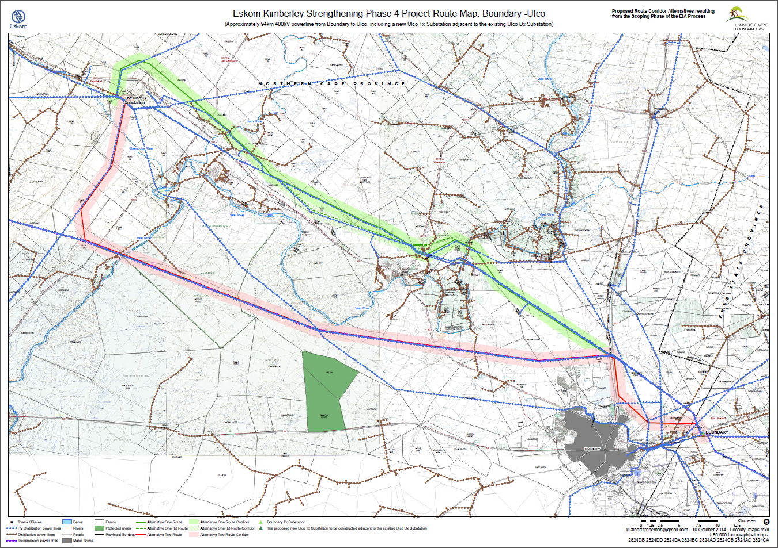
Figure 1: Map of the various proposed corridor alternatives for the Boundary - Ulco 400kV line

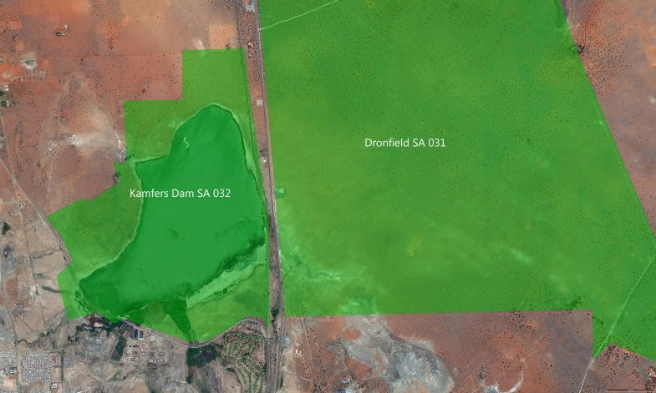
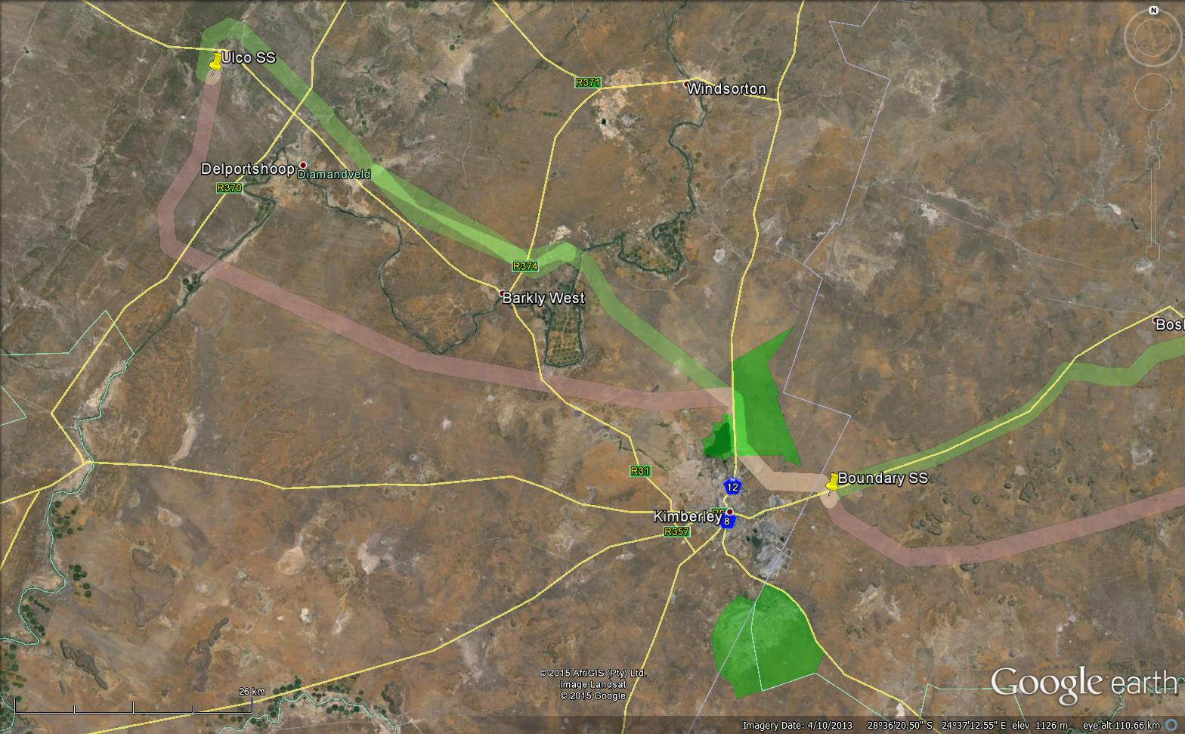
Dronfield SA 031
Kamfers Dam SA 032
Benfontein SA 033
Figure 2: Important Bird Areas (IBAs) in the study area.

4.2 Primary vegetation divisions (biomes)

The study area extends primarily over a single primary vegetation division, namely savanna (woodland) (Mucina & Rutherford 2006) (see Figure 3). It is generally accepted that vegetation structure, rather than the actual plant species, influences bird species distribution and abundance (Harrison et al. 1997). From an avifaunal perspective, the Atlas of southern African Birds (SABAP1) recognises six primary vegetation divisions or biomes within South Africa, namely (1) Fynbos (2) Succulent Karoo (3) Nama Karoo (4) Grassland (5) Savanna and (6) Forest (Harrison et al. 1997). These vegetation descriptions do not focus on lists of plant species, but rather on factors which are relevant to bird distribution. The criteria used by the SABAP1 authors to amalgamate botanically defined vegetation units, or to keep them separate were (1) the existence of clear differences in vegetation structure, likely to be relevant to birds, and (2) the results of published community studies on bird/vegetation associations.

4.3 Description of bird habitat classes

Whilst much of the distribution and abundance of the bird species in the study area can be explained by the composition of the natural vegetation, it is as important to also examine the modifications which have changed the natural landscape, and which may have an effect on the distribution of power line sensitive species. These are sometimes evident at a much smaller spatial scale than the biome types, and are determined by a host of factors such as vegetation type, topography, land use and man-made infrastructure. For purposes of the analysis in this report, the following bird habitat classes were defined from an avifaunal Red Data power line sensitive perspective (vegetation descriptions based largely on Harrison et al. 1997; Mucina & Rutherford 2006; Low & Robelo 1996):

4.3.1 Savanna

The study area is situated in savanna, and consists primarily of Kimberley Thornveld (between Kimberley and Delportshoop), Schmidtsdrif Thornveld (between Delportshoop and Ulco) with a few isolated areas of Vaalbos Rocky Shrubland, which only occurs on solitary hills and scattered ridges (see Figure 3). Kimberley Thornveld is an open savanna, with Umbrella Thorn Acacia tortilis and Camel Thorn A. erioloba the dominant tree species, and scattered individuals of Shepherd's Tree Boscia albitrunca and Sweet Thorn Acacia karroo. The shrub layer is poorly to moderately developed in places and individuals of Camphor Tree Tarchonanthus camphoratus, Spike-flowered Black Thorn Acacia mellifera, Wild Raisin Grewia flava and Lycium hirsutum occur widely scattered. The grass layer is fairly well developed and grasses such as Redgrass Themeda triandra, Common Nine-awn Grass Enneapogon cenchroides, Lehmann's Lovegrass Eragrostis lehmanniana, Elionurus muticus and Cymbopogon plurinodis are conspicuous. It is confined to sandy plains. The summer rainfall is 400 - 500mm per year. Temperature varies between -8°C and 41°C, with an average of 19°C. Schmidtsdrift Thornveld occurs mostly between Delportshoop and Ulco and is a closed shrubby thornveld dominated by Acacia mellifera and Acacia tortillis. Apart from grasses, bulbous and annual herbaceous plant species are also prominent. The vegetation is sometimes very disturbed due to overgrazing by goats and other browsers. The rainfall is in summer and autumn ranging from 250 – 450mm. Just west of Ulco Substation, the Ghaap Plateau starts with its distinctive Ghaap Plateau Vaalbosveld, which consists of a well-developed shrub layer of Tarchonanthus camphoratus with very few trees. Rainfall is in summer and autumn ranging from 300mm – 500mm, with temperatures ranging from -7.5°C to 36°C. The power line sensitive Red Data avifauna occurring in this habitat is typically arid woodland species i.e. Lappet-faced Vulture, White-backed Vulture, Cape Vulture, Tawny Eagle, Martial Eagle, Lanner Falcon, Verreaux’s Eagle (ridges and koppies), European Roller, Secretarybird and Kori Bustard.

4.3. 2 Pans

An important feature of the arid landscape where the proposed power line is located is the presence of pans (see Figure 3). Pans are endorheic wetlands having closed drainage systems; water usually flows in from small catchments but with no outflow from the pan basins themselves. They are characteristic of poorly drained, relatively flat and dry regions. Water loss is mainly through evaporation, sometimes resulting in saline conditions, especially in the most arid regions. Water depth is shallow (<3m), and flooding characteristically ephemeral (Harrison et al. 1997). When flooded, pans are important for a variety of power line sensitive Red Data species which occur in the study area e.g. Black Stork, Greater Flamingo, Lesser Flamingo, Abdim’s Stork, Chestnut-banded Plover, Greater Painted-snipe, Maccoa Duck and Yellow-billed Stork. Pans are also used by raptors and vultures for drinking and bathing. Double-banded Coursers and Burchell’s Coursers occur along the pan fringes and on dry pans. The most significant pan in the study area is Kamfers Dam outside Kimberley. A special feature is the large numbers (from a South African perspective) of Greater Flamingo and Lesser Flamingo that are found throughout the year. Kamfers Dam supports the largest permanent population of Lesser Flamingos in southern Africa, at times in excess of 80 000 individuals (Barnes 1998; BLSA 2014 - see also 4.1 above).

4.3.3 Rivers

The study area contains two major rivers, the Vaal River and its important northern tributary, the Harts River, which are important for a variety of waterbirds, including Red Data Black Stork and Yellow-billed Stork, while Abdim’s Stork are attracted to adjacent floodplain areas. Rivers are also corridors for woodland, which Kori Bustard often associate with.

4.3.4 Vulture breeding areas

A notable feature of the study area is the large number of breeding White-backed Vultures which are distributed in loose colonies over several areas within a 50km radius around Kimberley (see Figure 3). These colonies are situated in savanna areas where there are scattered, large Camel Thorn Acacia erioloba trees. The most important breeding colonies known at this stage are Dronfield, Mokala, Paardeberg, Secretarius, Rivermead and Susanna. The total number of nests is estimated at around 220+ (Murn et al. 2002; Wilson 2014). Both corridors run just south of Dronfield colony, consisting of approximately 65 breeding pairs, and a very active vulture restaurant. The Alternative One Route Corridor also crosses through the Rivermead colony, which currently holds 11 nests of which 5 are active (Wilson 2014). The small Secretarius vulture colony is not directly affected.

4.3.5 Agricultural lands

The study area contains extensive irrigated agricultural lands, mostly along the Vaal and Harts Rivers. Although agricultural lands completely destroy the structure of the original vegetation, some birds do benefit from this transformation. Abdim’s Stork and Ludwig’s Bustard (to a lesser extent) are the Red Data species most likely to utilise agricultural lands in the study area. Abdim’s Stork can occur in flocks of several hundred on irrigated fields.

4.3.6 Cliffs and ridges

The majority of the proposed alignments are located in topographically flat plains. However, in places the proposed alignments do cross steep terrain, specifically near Ulco substation, at the edge of the Ghaap Plateau, which consists of a series of low cliffs. These cliffs are potentially suitable roosting and breeding habitat for a number of Red Data power line sensitive species, e.g. Black Stork, Lanner Falcon, and Verreaux’s Eagle.

See Appendix 1 for a photographic record of the habitat classes

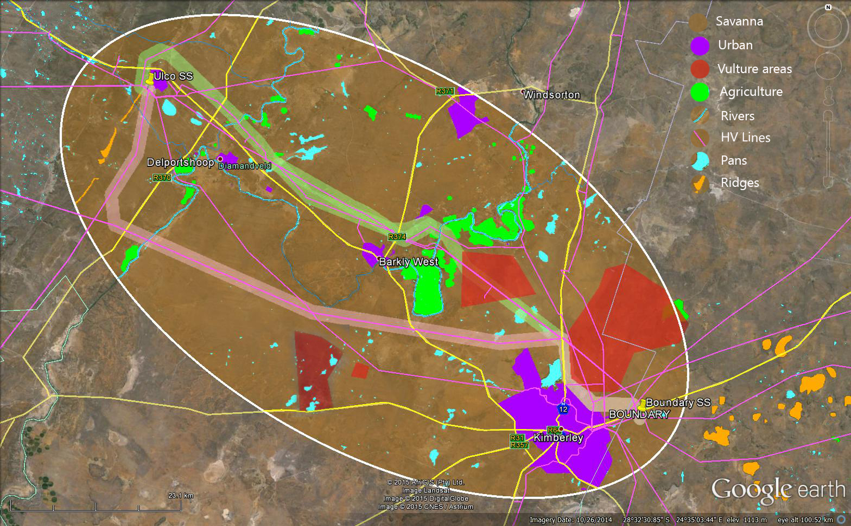
Figure 3: Habitat classes in the study area.

4.4 Power line sensitive species occurring in the study area

A total of 22 Red Data species have been recorded by SABAP2 in the QDGCs that are bisected by the two corridors (see Table 1). For each species, the potential for occurring in a specific habitat class was indicated, as well as the potential impact most likely associated with this specific species.

Table 1: Red Data species recorded by SABAP2 in the QDGCs that overlap with the study area. The QDGCs are 2824DB, 2824DA, 2824BC, 2824CB, 2824AD, 2824AC.

NT=Near threatened VU=Vulnerable EN = Endangered

Name | Scientific name | Conservation status | Rivers | Cliffs & ridges | Savanna | Pans | Agricultural lands | Vulture colonies | Collisions | Displacement through disturbance | Displacement through habitat destruction
Cape Vulture | Gyps coprotheres | EN | - | - | x | x | - | - | x | - | -
Kori Bustard | Ardeatis kori | NT | x | - | x | - | - | - | x | - | -
Lanner Falcon | Falco biarmicus | VU | - | x | x | x | X |  | x | - | -
Ludwig's Bustard | Neotos ludwigii | EN | - | - | x | x | X | - | x | - | -
Martial Eagle | Polemaetus bellicosus | EN | - | - | x | x | - | - | x | x | x
Abdim’s Stork | Ciconia abdimii | NT | x | - | - | x | X | - | x | - | -
Burchell’s Courser | Cursorius rufus | VU | - | - | - | x | X | - | x | - | -
Verreaux's Eagle | Aquila verreauxii | VU | - | x | - | - | - | - | x | x | -
White-backed Vulture | Gyps africanus | VU | - | - | x | x | - | x | x | x | x
Greater Painted - snipe | Rostratula benghalensis | VU | x | - | - | x | - | - | x | - | -
Black Stork | Ciconia nigra | VU | x | x | - | x | - | - | x | x | -

Name | Scientific name | Conservation status | Rivers | Cliffs & ridges | Savanna | Pans | Agricultural lands | Vulture colonies | Collisions | Displacement through disturbance | Displacement through habitat destruction
Secretarybird | Sagittarius serpentarius | VU | - | - | x | x | - | - | x | - | -
Tawny Eagle | Aquila rapax | EN | - | - | x | - | - | - | x | x | x
Yellow-billed Stork | Mycteria ibis | EN | x | - | - | x | - | - | x | - | -
Lesser Flamingo | Phoenicopterus minor | NT | - | - | - | x | - | - | x | - | -
Greater Flamingo | Phoenicopterus roseus | NT | - | - | - | x | - | - | x | - | -
Double-banded Courser | Rhinoptilus africanus | NT | - | - | - | x | - | - | x | - | -
Chestnut-banded Plover | Charadrius pallidus | NT | - | - | - | x | - | - | x | - | -
European Roller | Coracias garrulus | NT | - | - | x | - | - | - | - | - | -
Lappet-faced Vulture | Torgos tracheliotus | EN | - | - | x | - | - | - | x | x | x
Maccoa Duck | Oxyura maccoa | NT | - | - | - | x | - | - | x | - | -
Caspian Tern | Sterna caspia | VU | - | - | - | x | - | - | x | - | -

Description of expected impacts

Because of their size and prominence, electrical infrastructures constitute an important interface between wildlife and man. Negative interactions between wildlife and electricity structures take many forms, but two common problems in southern Africa are electrocution of birds (and other animals) and birds colliding with power lines. (Ledger and Annegarn 1981; Ledger 1983; Ledger 1984; Hobbs and Ledger 1986a; Hobbs and Ledger 1986b; Ledger, Hobbs and Smith, 1992; Verdoorn 1996; Kruger and Van Rooyen 1998; Van Rooyen 1998; Kruger 1999; Van Rooyen 1999; Van Rooyen 2000; Anderson 2001; Shaw 2013).

5.1 Electrocutions

Electrocution refers to the scenario where a bird is perched or attempts to perch on the electrical structure and causes an electrical short circuit by physically bridging the air gap between live components and/or live and earthed components (van Rooyen 2004). The electrocution risk is largely determined by the pole/tower design. Potential tower types that could be utilised for the 400kV line are self-supporting towers, cross-rope suspension towers and guyed-V towers. The topography will largely dictate the type of tower that will be used. Due to the large size of the clearances on overhead lines of 400kV, electrocutions are ruled out as even the largest birds cannot physically bridge the gap between energised and/or energised and earthed components. In summary it can be stated that the risk of electrocution posed to Red Data species by the new power line infrastructure is likely to be negligible.

5.2 Collisions

Collisions are probably the biggest single threat posed by transmission lines to birds in southern Africa (van Rooyen 2004; Shaw 2013). Most heavily impacted upon are bustards, storks, cranes and various species of waterbirds. These species are mostly heavy-bodied birds with limited manoeuvrability, which makes it difficult for them to take the necessary evasive action to avoid colliding with power lines (van Rooyen 2004; Anderson 2001; Shaw 2013).

In a recent PhD study, Shaw (2013) provides a concise summary of the phenomenon of avian collisions with power lines:

“The collision risk posed by power lines is complex and problems are often localised. While any bird flying near a power line is at risk of collision, this risk varies greatly between different groups of birds, and depends on the interplay of a wide range of factors (APLIC 1994). Bevanger (1994) described these factors in four main groups – biological, topographical, meteorological and technical. Birds at highest risk are those that are both susceptible to collisions and frequently exposed to power lines, with waterbirds, gamebirds, rails, cranes and bustards usually the most numerous reported victims (Bevanger 1998, Rubolini et al. 2005, Jenkins et al. 2010).

The proliferation of man-made structures in the landscape is relatively recent, and birds are not evolved to avoid them. Body size and morphology are key predictive factors of collision risk, with large-bodied birds with high wing loadings (the ratio of body weight to wing area) most at risk (Bevanger 1998, Janss 2000). These birds must fly fast to remain airborne, and do not have sufficient manoeuvrability to avoid unexpected obstacles. Vision is another key biological factor, with many collision-prone birds principally using lateral vision to navigate in flight, when it is the lower-resolution, and often restricted, forward vision that is useful to detect obstacles (Martin & Shaw 2010, Martin 2011, Martin et al. 2012). Behaviour is important, with birds flying in flocks, at low levels and in crepuscular or nocturnal conditions at higher risk of collision (Bevanger 1994). Experience affects risk, with migratory and nomadic species that spend much of their time in unfamiliar locations also expected to collide more often (Anderson 1978, Anderson 2002). Juvenile birds have often been reported as being more collision-prone than adults (e.g. Brown et al. 1987, Henderson et al. 1996).

Topography and weather conditions affect how birds use the landscape. Power lines in sensitive bird areas (e.g. those that separate feeding and roosting areas, or cross flyways) can be very dangerous (APLIC 1994, Bevanger 1994). Lines crossing the prevailing wind conditions can pose a problem for large birds that use the wind to aid take-off and landing (Bevanger 1994). Inclement weather can disorient birds and reduce their flight altitude, and strong winds can result in birds colliding with power lines that they can see but do not have enough flight control to avoid (Brown et al. 1987, APLIC 1994).

The technical aspects of power line design and siting also play a big part in collision risk. Grouping similar power lines on a common servitude, or locating them along other features such as tree lines, are both approaches thought to reduce risk (Bevanger 1994). In general, low lines with short span lengths (i.e. the distance between two adjacent pylons) and flat conductor configurations are thought to be the least dangerous (Bevanger 1994, Jenkins et al. 2010). On many higher voltage lines, there is a thin earth (or ground) wire above the conductors, protecting the system from lightning strikes. Earth wires are widely accepted to cause the majority of collisions on power lines with this configuration because they are difficult to see, and birds flaring to avoid hitting the conductors often put themselves directly in the path of these wires (Brown et al. 1987, Faanes 1987, Alonso et al. 1994a, Bevanger 1994).”

As mentioned by Shaw (2013) in the extract above, several factors are thought to influence avian collisions, including the manoeuvrability of the bird, topography, weather conditions and power line configuration. An important additional factor that previously has received little attention is the visual capacity of birds; i.e. whether they are able to see obstacles such as power lines, and whether they are they looking ahead to see obstacles with enough time to avoid a collision. In addition to helping explain the susceptibility of some species to collision, this factor is key to planning effective mitigation measures. Recent research provides the first evidence that birds can render themselves blind in the direction of travel during flight through voluntary head movements (Martin & Shaw 2010). Visual fields were determined in three bird species representative of families known to be subject to high levels of mortality associated with power lines i.e. Kori Bustards, Blue Cranes and White Storks Ciconia ciconia. In all species the frontal visual fields showed narrow and vertically long binocular fields typical of birds that take food items directly in the bill under visual guidance. However, these species differed markedly in the vertical extent of their binocular fields and in the extent of the blind areas which project above and below the binocular fields in the forward facing hemisphere. The importance of these blind areas is that when in flight, head movements in the vertical plane (pitching the head to look downwards) will render the bird blind in the direction of travel. Such movements may frequently occur when birds are scanning below them (for foraging or roost sites, or for conspecifics). In bustards and cranes pitch movements of only 25° and 35° respectively are sufficient to render the birds blind in the direction of travel; in storks head movements of 55° are necessary. That flying birds can render themselves blind in the direction of travel has not been previously recognised and has important implications for the effective mitigation of collisions with human artefacts including wind turbines and power lines. These findings have applicability to species outside of these families especially raptors (Accipitridae) which are known to have small binocular fields and large blind areas similar to those of bustards and cranes, and are also known to be vulnerable to power line collisions.

Thus visual field topographies which have evolved primarily to meet visual challenges associated with foraging may render certain bird species particularly vulnerable to collisions with human artefacts, such as power lines and wind turbines that extend into the otherwise open airspace above their preferred habitats. For these species placing devices upon power lines to render them more visible may have limited success since no matter what the device the birds may not see them. It may be that in certain situations it may be necessary to distract birds away from the obstacles, or encourage them to land nearby (for example by the use of decoy models of conspecifics, or the provision of sites attractive for roosting) since increased marking of the obstacle cannot be guaranteed to render it visible if the visual field configuration prevents it being detected. Perhaps most importantly, the results indicate that collision mitigation may need to vary substantially for different collision prone species, taking account of species specific behaviours, habitat and foraging preferences, since an effective all-purpose marking device is probably not realistic if some birds do not see the obstacle at all (Martin & Shaw 2010).
A significant impact that is foreseen for the proposed Boundary - Ulco transmission line is collisions with the earth wire of the proposed line. Quantifying this impact in terms of the likely number of birds that will be impacted, is very difficult because a large number of variables play a role in determining the risk, for example weather, rainfall, wind, age, flocking behaviour, power line height, light conditions, topography, population density and so forth. However, from incidental record keeping by the Endangered Wildlife Trust, it is possible to give a measure of what species are likely to be impacted upon (see Figure 4 below - Jenkins et al. 2010). This only gives a measure of the general susceptibility of the species to power line collisions, and not an absolute measurement for any specific line.

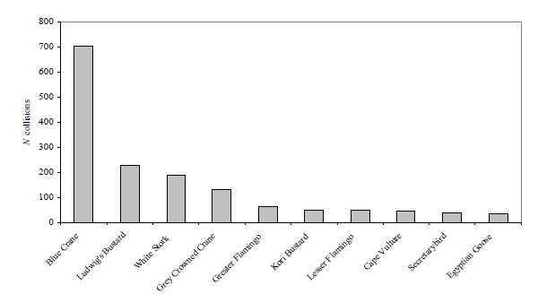
Figure 4: The top 10 collision prone bird species in South Africa, in terms of reported incidents contained in the Eskom/EWT Strategic Partnership central incident register 1996 - 2008 (Jenkins et al. 2010)

The most likely potential candidates for collision mortality on the proposed power line are Kori Bustard, Greater Flamingo, Lesser Flamingo, Secretarybird, Abdim’s Stork, White-backed Vulture, Yellow-billed Stork, Black Stork, Verreaux’s Eagle and Cape Vulture. Ludwig’s Bustard will also be at risk, based on the species flight characteristics and tendency to fly long distances between foraging and roosting areas and when migrating. Movements by this species are triggered by rainfall (Allan 1994), and so are inherently erratic and unpredictable in this arid environment, where the quantity and timing of rains are highly variable between years. However, the proposed corridors are both situated in the savanna biome, which is not the ideal habitat for the species - it was only reported in two QDGCs, with a maximum reporting rate of 2%. The highest risk for Ludwig’s Bustard is likely to be on irrigated fields and dry pans. Flamingos might be at risk near water bodies, particularly large pans. Kori Bustards might be at risk anywhere in the savanna habitat, particularly when flying to roost sites in the late afternoon and early evening. Secretarybirds will be most at risk in areas of open woodland with a prominent grass layer, and when descending to pans to drink. Abdim’s Stork will be at risk at pans, where they often roost in large numbers, and in irrigated areas, where they forage in large numbers. White-backed Vultures are at risk in breeding colonies, particularly in Dronfield Farm and Rivermead colonies. Cape Vultures are at risk in areas where they roost on transmission towers. Black Stork and Yellow-billed Stork will be at risk at river crossings and pans. Black Stork, Lanner Falcon and Verreaux’s Eagle might be at risk where the proposed lines cross the low cliffs at the edge of the Ghaap Plateau. Tawny Eagle, Martial Eagle and Lappet-faced Vulture might be at risk anywhere in savanna habitat, but particularly when descending to and leaving from pans when visiting to drink and bath. Burchell’s Courser, Double-banded Courser, Chestnut-banded Plover, Caspian Tern and Greater Painted-snipe are also potentially at risk of collisions, but less so than the larger species as they are more agile and therefore less likely to collide with the earthwires of the proposed lines.

5.3 Displacement due to habitat destruction and disturbance

During the construction phase and maintenance of power lines and substations, some habitat destruction and transformation inevitably takes place. This happens with the construction of access roads, the clearing of servitudes and the levelling of substation yards. Servitudes have to be cleared of excess vegetation at regular intervals in order to allow access to the line for maintenance, to prevent vegetation from intruding into the legally prescribed clearance gap between the ground and the conductors and to minimize the risk of fire under the line, which can result in electrical flashovers. These activities have an impact on birds breeding, foraging and roosting in or in close proximity of the servitude through transformation of habitat, which could result in temporary or permanent displacement. In the present instance, the risk of displacement of Red Data species due to habitat destruction is likely to be fairly limited, given the nature of the habitat. The one exception to the last statement is the White-backed Vulture breeding colonies, where the removal of large Camel Thorn trees could result in the destruction of nests, and the resultant displacement of breeding birds. As mentioned earlier, Alternative One Route Corridor bisects the small Rivermead colony (11 nests and 5 active pairs) which is of fairly minor importance compared to the large and very active Dronfield colony (89 nests and 65 active pairs). Both the route corridor alternatives are routed south of the Dronfield breeding areas and should therefore not impact directly on the breeding activity.

Apart from direct habitat destruction, the above mentioned construction and maintenance activities could also potentially impact on birds through disturbance, particularly at the aforementioned White-backed Vulture breeding colonies. This could lead to breeding failure if the disturbance happens during a critical part of the breeding cycle. Construction activities in close proximity could be a source of disturbance and could lead to temporary breeding failure or even permanent abandonment of nests. However, as mentioned earlier, the important Dronfield colony is not affected by any of the two corridors, and the potential impact on the Rivermead colony is fairly restricted on a regional scale due to limited significance of the colony at a regional level.

- Assessment of impacts and selection of a preferred alternative

One of the main objectives of this study is to arrive at a preferred corridor for the proposed transmission power lines, from an avifaunal interaction perspective. The methods that were followed to select a preferred corridor alternative are outlined below.

6.1 Methods

The potential for interaction with the proposed power line was assessed for each of the Red Data species listed in Table 1. This was done by assessing the probability of each potential impact (collisions, displacement through disturbance and displacement through habitat destruction) occurring, for each species, within each of the described habitat classes. The following probability scale was used: 1 = low, 2 = medium, 3 = high. Each habitat class therefore received a habitat score for each species. The habitat score was then multiplied with the national Red Data status of the species (Near Threatened = 1, Vulnerable = 2, Endangered = 3, Critically Endangered = 4) and the reporting rate for the species in the QDGC, to arrive at a risk score for each species for each habitat class (see Appendix 2). The total risk score for a habitat class was calculated as the sum of the various individual species risk scores for that habitat class.

Table 2 below gives the risk scores for each of the habitat classes:

Table 2: Risk scores for each habitat class

Habitat class | Risk score
Urban | 0
Powerlines | -78
Ridges | 44
Wetlands and waterbodies | 245
Rivers | 15
Agriculture | 31
Vulture colonies | 432
Savanna | 301

The risk scores in Table 2 were incorporated into a formula to arrive at a risk rating for each 2km wide corridor alternative. The surface area of each habitat class within a corridor was calculated. The risk rating for a route alternative corridor was calculated by multiplying the percentage that each habitat class constitute of the total surface area of the 2km wide corridor with the risk score for that habitat class, and then adding up the totals. In the GIS analysis, a hierarchical exclusion system was used to compile an avifaunal habitat map. The different habitat classes were layered in the following sequence (starting from the bottom i.e. each consecutive layer would exclude its underlying layers): Biome, vulture breeding area, agriculture, rivers, pans, ridges, power lines, urban. The risk ratings of the respective route alternative corridors are listed in Table 3 below, and in Appendix 3.

Table 3: Risk rating for each alternative corridor

BOUNDARY-ULCO | Risk rating
Alt 1 | 679.16
Alt 1A | 675.84
Alt 2 | 748.55

All the route alternative corridors emerged with very similar risk ratings, with only a 10% difference in ratings between the highest risk (Alternative Two Route Corridor) and the lowest risk (Alternative One A Route Corridor). This indicates that all the various route alternative corridors are very similar as far as envisaged impacts on avifauna are concerned. The main reason for Alternative One/A Route Corridor emerging with a slightly lower risk rating than Alternative Two Route Corridor is the fact that the latter is 17% longer than the former. However, the scoring system does not account for risk factors lying beyond the boundaries of the 2km corridor. In the case of avifauna, it may on occasion be necessary to consider factors beyond the 2km corridor to better assess the collision risk that a new line poses. In this instance, a section of Alternative One/A Route Corridor is located between two areas of agriculture along the Harts River which is located largely beyond the 2km corridor boundaries, which most likely acts as a focal point for collision sensitive species such as Ludwig’s Bustard and Abdim’s Stork. It is highly likely that there is regular traffic of these species and other non-Red Data species of avifauna between these two agricultural areas, which would expose them to a collision risk. If this is taken into account, the scales tilt towards Alternative Two Route Corridor as the preferred option, despite it being a longer route. In addition, Alternative One/A Route Corridor cuts through the Rivermead vulture colony, which although a minor colony, is not a desirable outcome.

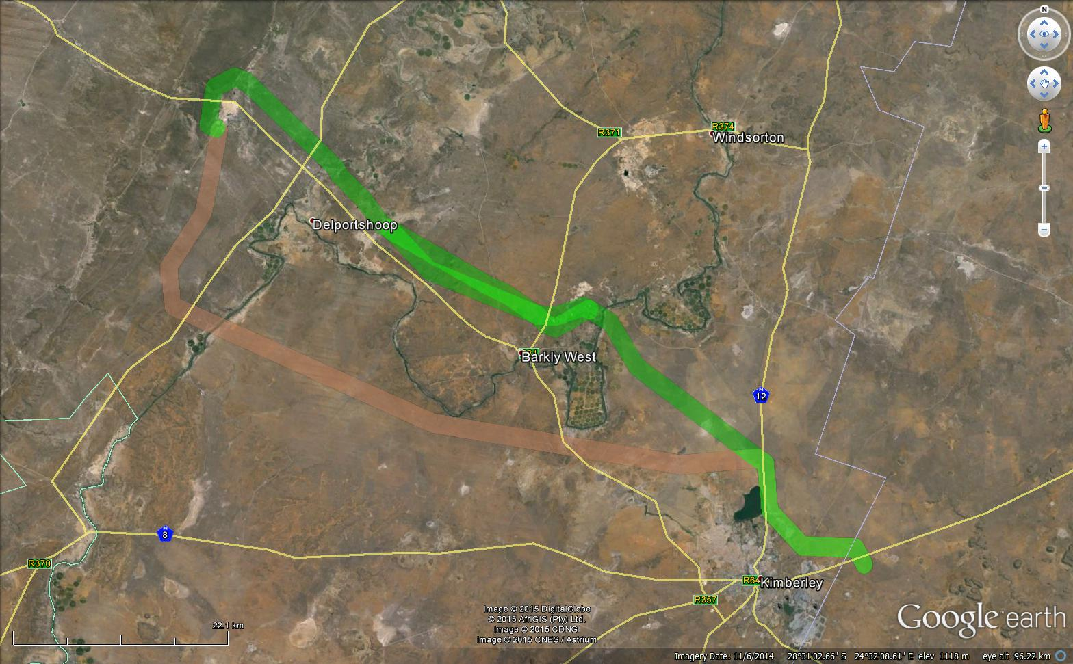
Figure 5: A map indicating the two agricultural areas which acts as focal points for collision sensitive avifauna.

6 Assessment of impacts

The impact assessment methodology makes provision for the assessment of impacts against the following criteria:

- Extent of impact
- Duration of impact
- Probability of impact
- Magnitude/Intensity of impact
- Significance of impact

Extent of impact | Explanation of extent
Site | Impacts limited to construction site and direct surrounding area
Local | Impacts affecting environmental elements within the local area / district
Regional | Impacts affecting environmental elements within the province
National | Impacts affecting environmental elements on a national level
Global | Impacts affecting environmental elements on a global level

Duration of impact | Explanation of duration
Short term | 0 - 5 years. The impact is reversible in less than 5 years.
Medium term | 5 - 15 years. The impact is reversible in less than 15 years.
Long term | >15 years, but where the impacts will cease if the project is decommissioned
Permanent | The impact will continue indefinitely and is irreversible.

Probability of impact | Explanation of Probability
Unlikely | The chance of the impact occurring is extremely low
Possible | The impact may occur
Probable | The impact will very likely occur
Definite | Impact will certainly occur

Magnitude/Intensity of impact | Explanation of Magnitude/Intensity
Low | Where the impact affects the environment in such a way that natural, social and cultural functions and processes are not affected
Moderate | Where the affected environment is altered, but natural, social and cultural functions and processes continue albeit in a modified way
Severe | Where natural, social and cultural functions or processes are altered to the extent that it will temporarily or permanently cease

Significance of impact | Explanation of Significance
None | There is no impact at all
Low | Impact is negligible or is of a low order and is likely to have little real effect
Moderate | Impact is real but not substantial
High | Impact is substantial
Very high | Impact is very high and can therefore influence the viability of the project

Alternative One Route Corridor
Impact Description | Extent  Site / Local /  Regional /  National / Global | Duration  Short / Medium / Long / Permanent | Probability  Unlikely / Possible / Probable / Definite | Magnitude / Intensity  Low / Moderate / Severe | Significance of Impact  without Mitigation  None, Low, Moderate, High, Very High | Significance of Impact  After Mitigation  None, Low, Moderate, High, Very High
Displacement of Red Data species through disturbance during the construction of the proposed transmission line | Site | Short term | Probable | Low | Moderate/High | Low
Displacement of Red Data species through habitat destruction due to the construction of the proposed transmission line | Site | Short term | Probable | Low | Moderate/High | Low
Mortality of Red Data species due to collisions with the earth wire of the proposed transmission line | Regional | Long term | Definite | Moderate | High | Moderate

Alternative One A Route Corridor
Impact Description | Extent  Site / Local /  Regional /  National / Global | Duration  Short / Medium / Long / Permanent | Probability  Unlikely / Possible / Probable / Definite | Magnitude / Intensity  Low / Moderate / Severe | Significance of Impact  without Mitigation  None, Low, Moderate, High, Very High | Significance of Impact  After Mitigation  None, Low, Moderate, High, Very High
Displacement of Red Data species through disturbance during the construction of the proposed transmission line | Site | Short term | Probable | Low | Moderate/High | Low
Displacement of Red Data species through habitat destruction due to the construction of the proposed transmission line | Site | Short term | Probable | Low | Moderate/High | Low
Mortality of Red Data species due to collisions with the earth wire of the proposed transmission line | Regional | Long term | Definite | Moderate | High | Moderate

Alternative Two Route Corridor
Impact Description | Extent  Site / Local /  Regional /  National / Global | Duration  Short / Medium / Long / Permanent | Probability  Unlikely / Possible / Probable / Definite | Magnitude / Intensity  Low / Moderate / Severe | Significance of Impact  without Mitigation  None, Low, Moderate, High, Very High | Significance of Impact  After Mitigation  None, Low, Moderate, High, Very High
Displacement of Red Data species through disturbance during the construction of the proposed transmission line | Site | Short term | Possible | Low | Moderate | Low
Displacement of Red Data species through habitat destruction due to the construction of the proposed transmission line | Site | Short term | Possible | Low | Moderate | Low
Mortality of Red Data species due to collisions with the earth wire of the proposed transmission line | Regional | Long term | Probable | Moderate | Moderate | Low

7 Mitigation

Any attempt at quantifying the potential bird impacts for the proposed development would entail the collection of significant amounts of quantitative data, for example one would have to establish how many pairs of a given species are using a particular area of woodland and document the potential breeding failure through disturbance that could occur if a transmission line is constructed through that area of woodland. Then the influence of this impact on the ability of the local, regional or even national population to persist would have to be documented and quantified. Clearly such detailed studies fall outside the scope of this report. The fact that impacts such as habitat destruction and disturbance could be significant but difficult to quantify, requires that all possible mitigation measures should be implemented on the basis of the pre-cautionary principle. The World Charter for Nature, which was adopted by the UN General Assembly in 1982, was the first international endorsement of the precautionary principle. The principle was implemented in an international treaty as early as the 1987 Montreal Protocol and among other international treaties and declarations is reflected in the 1992 Rio Declaration on Environment and Development. Principle 15 of the Rio Declaration 1992 states that: “in order to protect the environment, the precautionary approach shall be widely applied by States according to their capabilities. Where there are threats of serious or irreversible damage, lack of full scientific certainty shall be not used as a reason for postponing cost-effective measures to prevent environmental degradation.”.

There are many methods that can be used to mitigate avian power line interactions and several investigations dealing with the collision problem have focused on finding suitable mitigation measures (see for example APLIC 2012 and Shaw 2013). The most proactive measures are power line route planning (and the subsequent avoidance of areas with a high potential for bird strikes) and the modification of power line designs (this option includes line relocations, underground burial of lines, removal of over-head ground wires, and the marking of ground wires to make them more visible to birds in flight). In many instances, decisions on power line placement and possible mitigation measures are however eventually based on economic factors. The relocation of an existing line is the last option that is usually considered when trying to mitigate avian collisions. The huge expense of creating a new line and servitude usually cannot be justified unless there are biologically significant mortalities. Underground burial of power lines is another option available to utility companies in areas of high collision risk. This will obviously eliminate collisions, but the method has many drawbacks. The costs of burying lines can be from 20 – 30 times (or more) higher than constructing overhead lines, and such costs are related to the line voltage, type and length of cable, cable insulation, soil conditions, local regulations, reliability requirements, and requirement of termination areas. Limitations of cable burial include: no economically feasible methods of burying extra high voltage lines have been developed, there is a potential to contaminate underground water supplies if leakage of oil used in insulating the lines occurs, and extended outage risks due to the difficulty in locating cable failures (APLIC 2012). Since most strikes involve earth-wires (more than 80% of observed bird collisions), the removal of these wires would decrease the number of collisions. It is assumed that the large number of earth-wire collisions is because birds react to the more visible conductors by flaring and climbing and then collide with the thinner earth-wires (Anderson 2001). Earth-wire removal is, however, not a simple matter. Due to the need for lightning protection and other types of electricity overload, it is only possible on lower-voltage power lines (where polymer lightning arresters can be used). The marking of overhead earth-wires to increase their visibility is usually considered to be the most economical mitigation option for reducing collision mortality (APLIC 2012, Shaw 2013). This is particular so for the thousands of kilometres of established power lines through areas of high potential for avian interaction which cannot be rerouted.

Several factors are thought to influence avian collisions, including the manoeuvrability of the bird, topography, weather conditions and power line configuration. An important additional factor that previously has received little attention is the visual capacity of birds; i.e. whether they are able to see obstacles such as power lines, and whether they are they looking ahead to see obstacles with enough time to avoid a collision. In addition to helping explain the susceptibility of some species to collision, this factor is key to planning effective mitigation measures (Martin et al. 2010). Recent research conducted by Eskom and the Endangered Wildlife Trust provides the first evidence that birds can render themselves blind in the direction of travel during flight through voluntary head movements. Due to the variation in visual fields among species, there is unlikely to be a single solution for mitigating all collisions. Line marking alone is likely to be effective for storks, but for birds such as bustards, additional mitigation may be necessary, as these birds may not see obstacles at all when in flight. Distracting such birds away from obstacles or encouraging them to land nearby may help to prevent collisions, as they would be more aware of their surroundings and of marked power lines when taking off again (Martin et al. 2010). In certain situations birds such as bustards, cranes and raptors are unlikely to see ahead of them, no matter what mitigation measures are placed upon the actual obstacle. This is because the visual field configuration, coupled with possible head movements associated with searching below, prevents it being detected. For these species it may be better to distract birds away from, or encourage them to land nearby to power lines. Placing markers on the ground might have this effect. Bird silhouettes, painted drums or flags could prove effective, and it is recommended that such methods be used in combination with line marking. Unfortunately, no research is available on the effectiveness of ground marking.

However, despite doubts about the efficacy of line marking to reduce the collision risk for bustards (Jenkins et al. 2010; Martin et al. 2010), there are numerous studies which prove that marking a line with PVC spiral type Bird Flight Diverters (BFDs) generally reduce mortality rates (e.g. Barrientos et al. 2011; Jenkins et al. 2010; Alonso & Alonso 1999; Koops & De Jong 1982), even for bustards (Barrientos et al. 2012). Beaulaurier (1981) summarised the results of 17 studies that involved the marking of earth wires and found an average reduction in mortality of 45%. A Spanish study (Barrientos et al 2011) reviewed the results of 15 wire marking experiments in which transmission or distribution wires were marked to examine the effectiveness of flight diverters in reducing bird mortality. The presence of flight diverters was associated with a decrease in bird collisions. At unmarked lines, there were 0.21 deaths/1000 birds (n = 339,830) that flew among lines or over lines. At marked lines, the mortality rate was 78% lower (n = 1,060,746). Koops and De Jong (1982) found that the spacing of the BFDs were critical in reducing the mortality rates - mortality rates are reduced up to 86% with a spacing of 5 metres, whereas using the same devices at 10 metre intervals only reduces the mortality by 57%. Barrientos et al. (2012) found that larger BFDs were more effective in reducing Great Bustard collisions than smaller ones. Line markers should be as large as possible, and highly contrasting with the background. Colour is probably less important as during the day the background will be brighter than the obstacle with the reverse true at lower light levels (e.g. at twilight, or during overcast conditions). Black and white interspersed patterns are likely to maximise the probability of detection (Martin et al. 2010).

It is not the objective of this report to attempt to demarcate all sections of power line for all the alternative corridors that would need to be mitigated for potential collisions or disturbance of Red Data breeding species. This can only be done once the final alignments have been selected and tower positions have been finalized. At this stage, the following recommendations are put forward from a potential bird impact perspective:

- For the reasons stated above, Alternative Two Route Corridor is assessed to be the alternative with the lowest risk to birds. It is therefore recommended that this alternative is used.
- If Alternative One/A Route Corridor is selected, prior to construction commencing, an inspection should be conducted in the area where the corridor bisects the Rivermead vulture breeding area in order for the avifaunal specialist to record any White-backed Vulture nests that could be impacted by the construction of the proposed line. Should any nests be recorded, it would require management of the potential impacts on the breeding birds once construction commences, which would necessitate the involvement of the avifaunal specialist, and the Environmental Control Officer. An effective communication strategy should be implemented whereby the avifaunal specialist is provided with a construction schedule which will enable him to ascertain when and where breeding vultures could be impacted by the construction activities. This could then be addressed through the timing of construction activities during critical periods of the breeding cycle, once it has been established that a particular nest is active.
- Once the final alignments and tower positions have been selected, the sections of the line that would need the application of Bird Flight Diverters to mitigate for potential collisions should be indicated by the avifaunal specialist by means of a “walk-through” exercise. This exercise should be informed by an analysis of satellite imagery supplemented by on site ground-truthing (physical inspection). The type of Bird Flight Diverter to be used and the marking scheme will be determined during that phase of the project.
- The Eskom standard procedure with regard to the clearing of vegetation must be strictly adhered to, to minimise the extent of habitat destruction and disturbance during the construction phase. Existing roads should be used as far as possible to prevent further habitat fragmentation through the construction of new access roads, and to limit the construction footprint.

8 REFERENCES

Allan, D.G. 1994. The abundance and movements of Ludwig’s Bustard Neotis ludwigii. Ostrich 65: 95-105.

Alonso, J.A. & Alonso, C.A. 1999. Mitigation of bird collisions with transmission lines through groundwire marking. In: Birds and Power Lines Eds: M. Ferrer & G. F. E. Janss, Quercus, Madrid.

Anderson, M.D. 2001. The effectiveness of two different marking devices to reduce large terrestrial bird collisions with overhead electricity cables in the eastern Karoo, South Africa. Draft report to Eskom Resources and Strategy Division. Johannesburg. South Africa.

Avian Power Line Interaction Committee (APLIC). 2012. Reducing Avian Collisions with Power Lines: The State
of the Art in 2012. Edison Electric Institute and APLIC. Washington, D.C.

Barnes, K.N. (ed.) 1998. The Important Bird Areas of southern Africa. BirdLife South Africa: Johannesburg.

Barnes, K.N. (ed.) 2000. The Eskom Red Data Book of Birds of South Africa, Lesotho and Swaziland. BirdLife South Africa: Johannesburg.

Beaulaurier, D.L. 1981. Mitigation of bird collisions with transmission lines. Bonneville Power Administration. U.S. Dept. of Energy

BLSA 2014. http://www.birdlife.org.za/conservation/important-bird-areas/iba-directory

Barrientos, R., Alonso, J.C., Ponce, C., Palacín, C. 2011. Meta-Analysis of the effectiveness of marked wire in reducing avian collisions with power lines. Conservation Biology 25: 893-903.

Barrientos, R., Ponce, C., Palacín, C., Martín, C.A., Martín, B. and Alonso, J.C. 2012. Wire marking results in a small but significant reduction in avian mortality at power lines: a BACI designed study. PLos One 7: 1-10.
Harrison, J.A., Allan, D.G., Underhill, L.G., Herremans, M., Tree, A.J., Parker, V and Brown, C.J. (eds). 1997. The atlas of southern African birds. Vol. 1&2. BirdLife South Africa: Johannesburg.

Hobbs, J.C.A. and Ledger J.A. 1986a. The Environmental Impact of Linear Developments; Power lines and Avifauna. (Third International Conference on Environmental Quality and Ecosystem Stability. Israel, June 1986).

Hobbs, J.C.A. and Ledger J.A. 1986b. “Power lines, Birdlife and the Golden Mean.” Fauna and Flora, 44, pp 23-27.

Hockey P.A.R., Dean W.R.J., And Ryan P.G. (2005). Robert’s Birds of Southern Africa, seventh edition. Trustees of the John Voelcker Bird Book Fund, Cape Town.

Jenkins, A. & Smallie, J. 2009. Terminal velocity: the end of the line for Ludwig’s Bustard? Africa Birds and Birding. Vol 14, No 2.

Jenkins, A.R., Smallie, J.J. & Diamond, M. 2010. Avian collisions with power lines: a global review of causes and mitigation with a South African perspective. Bird Conservation International 20: 263-278.

Koops, F.B.J. & De Jong, J. 1982. Vermindering van draadslachtoffers door markering van hoogspanningsleidingen in de omgeving van Heerenveen. Electrotechniek 60 (12): 641 – 646.
Kruger, R. and Van Rooyen, C.S. 1998. Evaluating the risk that existing power lines pose to large raptors by using risk assessment methodology: the Molopo Case Study. (5th World Conference on Birds of Prey and Owls: 4 - 8 August 1998. Midrand, South Africa.)

Kruger, R. 1999. Towards solving raptor electrocutions on Eskom Distribution Structures in South Africa. M. Phil. Mini-thesis. University of the Orange Free State. Bloemfontein. South Africa.

Ledger, J. 1983. Guidelines for Dealing with Bird Problems of Transmission Lines and Towers. Escom Test and Research Division Technical Note TRR/N83/005.

Ledger, J.A. and Annegarn H.J. 1981. “Electrocution Hazards to the Cape Vulture (Gyps coprotheres) in South Africa”. Biological Conservation, 20, pp15-24.

Ledger, J.A. 1984. “Engineering Solutions to the problem of Vulture Electrocutions on Electricity Towers.” The Certificated Engineer, 57, pp 92-95.

Ledger, J.A., J.C.A. Hobbs and Smith T.V. 1992. Avian Interactions with Utility Structures: Southern African Experiences. (Proceedings of the International Workshop on Avian Interactions with Utility Structures, Miami, Florida, 13-15 September 1992. Electric Power Research Institute.)

Low, A.B. and Rebelo, A.G. (eds.) 1996. Vegetation of South Africa, Lesotho and Swaziland. Department of Environmental Affairs and Tourism, Pretoria.

Martin, G.R., Shaw, J.M. 2010. Bird collisions with power lines: Failing to see the way ahead?. Biol. Conserv. (2010), doi:10.1016/j.biocon.2010.07.014.

Mucina. L. & Rutherford, M.C. (Eds) 2006. The vegetation of South Africa, Lesotho and Swaziland. Strelitzia 19. South African National Biodiversity Institute, Pretoria.

Murn, C., Anderson, M.D. & Anthony, A. 2002. South African Journal of Wildlife Research 32(2): 145–152 (October 2002)

National Land Cover Project. 2009. www.bgis.sanbi.org.

Shaw, J.M. 2013. Power line collisions in the Karoo: Conserving Ludwig’s Bustard. Unpublished PhD thesis. Percy FitzPatrick Institute of African Ornithology, Department of Biological Sciences, Faculty of Science University of Cape Town May 2013.

Southern African Bird Atlas Project 2 (SABAP2). http://sabap2.adu.org.za.

Taylor, M.R. (ed.) 2014. The Eskom Red Data Book of Birds of South Africa, Lesotho and Swaziland. BirdLife South Africa, Johannesburg. In press.

Van Rooyen, C.S. and Ledger, J.A. 1999. “Birds and utility structures: Developments in southern Africa” in Ferrer, M. & G..F.M. Janns. (eds.) Birds and Power lines. Quercus: Madrid, Spain, pp 205-230

Van Rooyen, C.S. 1998. Raptor mortality on power lines in South Africa. (5th World Conference on Birds of Prey and Owls: 4 - 8 August 1998. Midrand, South Africa.)

Van Rooyen, C.S. 1999. An overview of the Eskom - EWT Strategic Partnership in South Africa. (EPRI Workshop on Avian Interactions with Utility Structures 2-3 December 1999, Charleston, South Carolina.)

Van Rooyen, C.S. 2000. “An overview of Vulture Electrocutions in South Africa.” Vulture News, 43, pp 5-22. Vulture Study Group: Johannesburg, South Africa.

Van Rooyen, C.S. 2003. Mitigation programme for Avian Collisions with Eskom Transmission Lines. Unpublished Progress Report, September 2003. Endangered Wildlife Trust, Johannesburg, South Africa.

Van Rooyen, C.S. 2004. The Management of Wildlife Interactions with overhead lines. In The fundamentals and practice of Overhead Line Maintenance (132kV and above), pp217-245. Eskom Technology, Services International, Johannesburg.

Verdoorn, G.H. 1996. Mortality of Cape Griffons Gyps coprotheres and African Whitebacked Vultures Pseudogyps africanus on 88kV and 132kV power lines in Western Transvaal, South Africa, and mitigation measures to prevent future problems. (2nd International Conference on Raptors: 2-5 October 1996. Urbino, Italy.)

Wilson, B. 2014. Results of aerial survey of White-backed Vulture colonies around Kimberley. Unpublished data.

APPENDIX 1: BIRD HABITATS
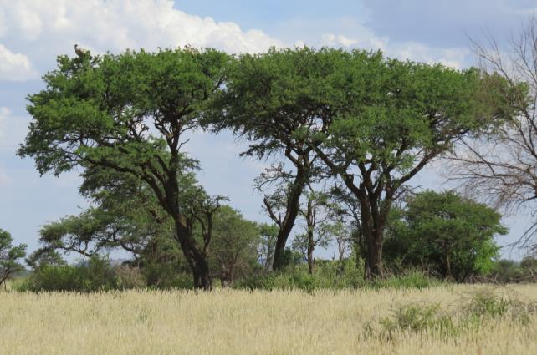
Figure 1: White-backed Vulture nest in the Dronfield vulture breeding area
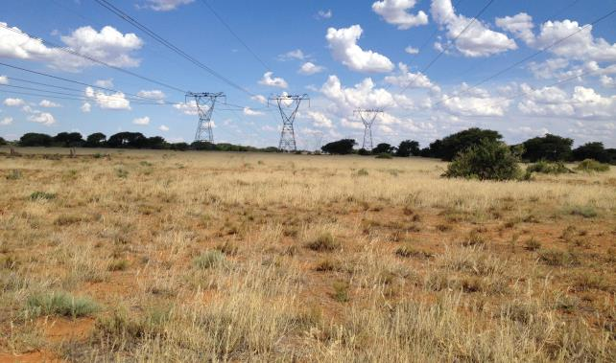
Figure 2: Existing HV lines in the Dronfield vulture breeding area in typical Kimberley Thornveld savanna

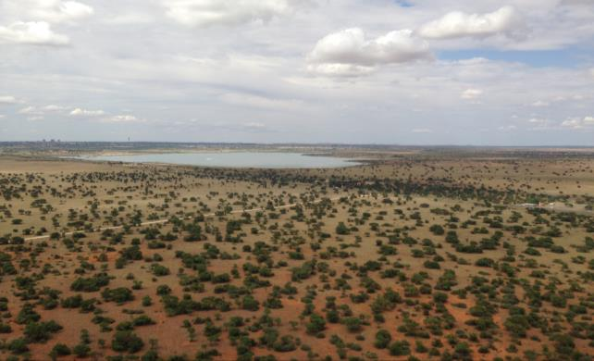
Figure 3: Kamfers Dam

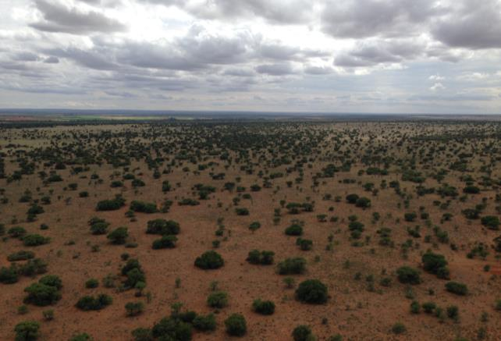
Figure 4: Rivermead vulture breeding area

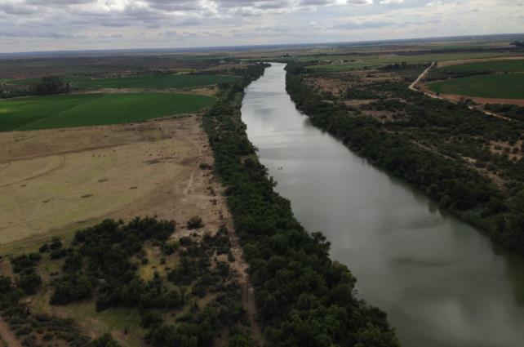
Figure 5: Agriculture along the Harts River
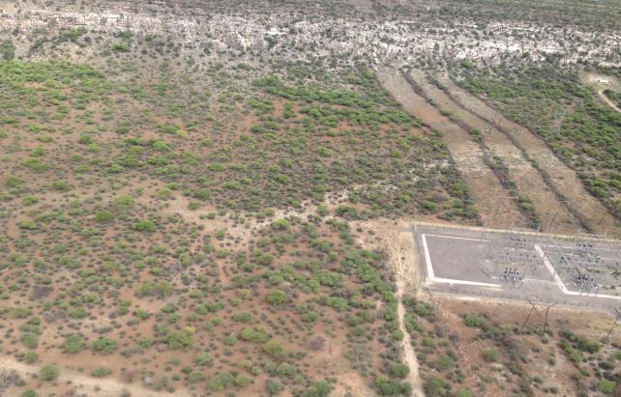
Figure 6: Cliffs at the edge of the Ghaap Plateau near Ulco Substation

APPENDIX 2: SPECIES SPECIFIC RISK SCORES
Lappet-faced Vuture | Collisions | Disturbance | Habitat destruction | Red Data score | Reporting rate | Total
Urban | 0 | 0 | 0 | 3 | 2 | 0
Powerlines | -1 | 0 | 0 | 3 | 2 | -6
Ridges | 0 | 0 | 0 | 3 | 2 | 0
Wetlands and waterbodies | 1 | 0 | 0 | 3 | 2 | 6
Rivers | 0 | 0 | 0 | 3 | 2 | 0
Agriculture | 0 | 0 | 0 | 3 | 2 | 0
Vulture colonies | 0 | 0 | 0 | 3 | 2 | 0
Savanna | 1 | 1 | 1 | 3 | 2 | 18
Ludwig's Bustard | Collisions | Disturbance | Habitat destruction | Red Data score | Reporting rate | Total
Urban | 0 | 0 | 0 | 3 | 1 | 0
Powerlines | -1 | 0 | 0 | 3 | 1 | -3
Ridges | 0 | 0 | 0 | 3 | 1 | 0
Wetlands and waterbodies | 0 | 0 | 0 | 3 | 1 | 0
Rivers | 0 | 0 | 0 | 3 | 1 | 0
Agriculture | 1 | 0 | 0 | 3 | 1 | 3
Vulture colonies | 0 | 0 | 0 | 3 | 1 | 0
Savanna | 0 | 0 | 0 | 3 | 1 | 0
Martial Eagle | Collisions | Disturbance | Habitat destruction | Red Data score | Reporting rate | Total
Urban | 0 | 0 | 0 | 3 | 1 | 0
Powerlines | -1 | 1 | 0 | 3 | 1 | 0
Ridges | 0 | 0 | 0 | 3 | 1 | 0
Wetlands and waterbodies | 1 | 0 | 0 | 3 | 1 | 3
Rivers | 0 | 0 | 0 | 3 | 1 | 0
Agriculture | 0 | 0 | 0 | 3 | 1 | 0
Vulture colonies | 0 | 0 | 0 | 3 | 1 | 0
Savanna | 1 | 1 | 0 | 3 | 1 | 6
Tawny Eagle | Collisions | Disturbance | Habitat destruction | Red Data score | Reporting rate | Total
Urban | 0 | 0 | 0 | 3 | 1 | 0
Powerlines | -1 | 1 | 0 | 3 | 1 | 0
Ridges | 0 | 0 | 0 | 3 | 1 | 0
Wetlands and waterbodies | 1 | 0 | 0 | 3 | 1 | 3
Rivers | 0 | 0 | 0 | 3 | 1 | 0
Agriculture | 0 | 0 | 0 | 3 | 1 | 0
Vulture colonies | 0 | 0 | 0 | 3 | 1 | 0
Savanna | 1 | 1 | 1 | 3 | 1 | 9
White-backed Vulture | Collisions | Disturbance | Habitat destruction | Red Data score | Reporting rate | Total
Urban | 0 | 0 | 0 | 3 | 16 | 0
Powerlines | -1 | 1 | 0 | 3 | 16 | 0
Ridges | 0 | 0 | 0 | 3 | 16 | 0
Wetlands and waterbodies | 1 | 0 | 0 | 3 | 16 | 48
Rivers | 0 | 0 | 0 | 3 | 16 | 0
Agriculture | 0 | 0 | 0 | 3 | 16 | 0
Vulture colonies | 3 | 3 | 3 | 3 | 16 | 432
Savanna | 1 | 1 | 1 | 3 | 16 | 144
Yellow-billed Stork | Collisions | Disturbance | Habitat destruction | Red Data score | Reporting rate | Total
Urban | 0 | 0 | 0 | 3 | 0 | 0
Powerlines | 0 | 0 | 0 | 3 | 0 | 0
Ridges | 0 | 0 | 0 | 3 | 0 | 0
Wetlands and waterbodies | 0 | 0 | 0 | 3 | 0 | 0
Rivers | 0 | 0 | 0 | 3 | 0 | 0
Agriculture | 0 | 0 | 0 | 3 | 0 | 0
Vulture colonies | 0 | 0 | 0 | 3 | 0 | 0
Savanna | 0 | 0 | 0 | 3 | 0 | 0
Abdim's Stork | Collisions | Disturbance | Habitat destruction | Red Data score | Reporting rate | Total
Urban | 0 | 0 | 0 | 1 | 2 | 0
Powerlines | -1 | 0 | 0 | 1 | 2 | -2
Ridges | 0 | 0 | 0 | 1 | 2 | 0
Wetlands and waterbodies | 2 | 1 | 0 | 1 | 2 | 6
Rivers | 0 | 0 | 0 | 1 | 2 | 0
Agriculture | 3 | 2 | 0 | 1 | 2 | 10
Vulture colonies | 0 | 0 | 0 | 1 | 2 | 0
Savanna | 0 | 0 | 0 | 1 | 2 | 0
Double-banded Courser | Collisions | Disturbance | Habitat destruction | Red Data score | Reporting rate | Total
Urban | 0 | 0 | 0 | 1 | 7 | 0
Powerlines | -1 | 0 | 0 | 1 | 7 | -7
Ridges | 0 | 0 | 0 | 1 | 7 | 0
Wetlands and waterbodies | 0 | 0 | 0 | 1 | 7 | 0
Rivers | 0 | 0 | 0 | 1 | 7 | 0
Agriculture | 1 | 1 | 0 | 1 | 7 | 14
Vulture colonies | 0 | 0 | 0 | 1 | 7 | 0
Savanna | 0 | 0 | 0 | 1 | 7 | 0
European Roller | Collisions | Disturbance | Habitat destruction | Red Data score | Reporting rate | Total
Urban | 0 | 0 | 0 | 1 | 2 | 0
Powerlines | -1 | 0 | 0 | 1 | 2 | -2
Ridges | 0 | 0 | 0 | 1 | 2 | 0
Wetlands and waterbodies | 0 | 0 | 0 | 1 | 2 | 0
Rivers | 0 | 0 | 0 | 1 | 2 | 0
Agriculture | 0 | 0 | 0 | 1 | 2 | 0
Vulture colonies | 0 | 0 | 0 | 1 | 2 | 0
Savanna | 0 | 1 | 1 | 1 | 2 | 4
Greater Flamingo | Collisions | Disturbance | Habitat destruction | Red Data score | Reporting rate | Total
Urban | 0 | 0 | 0 | 1 | 7 | 0
Powerlines | -1 | 0 | 0 | 1 | 7 | -7
Ridges | 0 | 0 | 0 | 1 | 7 | 0
Wetlands and waterbodies | 3 | 3 | 1 | 1 | 7 | 49
Rivers | 0 | 0 | 0 | 1 | 7 | 0
Agriculture | 0 | 0 | 0 | 1 | 7 | 0
Vulture colonies | 0 | 0 | 0 | 1 | 7 | 0
Savanna | 0 | 0 | 0 | 1 | 7 | 0
Kori Bustard | Collisions | Disturbance | Habitat destruction | Red Data score | Reporting rate | Total
Urban | 0 | 0 | 0 | 1 | 16 | 0
Powerlines | -1 | 0 | 0 | 1 | 16 | -16
Ridges | 0 | 0 | 0 | 1 | 16 | 0
Wetlands and waterbodies | 0 | 0 | 0 | 1 | 16 | 0
Rivers | 0 | 0 | 0 | 1 | 16 | 0
Agriculture | 0 | 0 | 0 | 1 | 16 | 0
Vulture colonies | 0 | 0 | 0 | 1 | 16 | 0
Savanna | 2 | 1 | 0 | 1 | 16 | 48
Lesser Flamingo | Collisions | Disturbance | Habitat destruction | Red Data score | Reporting rate | Total
Urban | 0 | 0 | 0 | 1 | 12 | 0
Powerlines | -1 | 0 | 0 | 1 | 12 | -12
Ridges | 0 | 0 | 0 | 1 | 12 | 0
Wetlands and waterbodies | 3 | 3 | 1 | 1 | 12 | 84
Rivers | 0 | 0 | 0 | 1 | 12 | 0
Agriculture | 0 | 0 | 0 | 1 | 12 | 0
Vulture colonies | 0 | 0 | 0 | 1 | 12 | 0
Savanna | 0 | 0 | 0 | 1 | 12 | 0
Maccoa Duck | Collisions | Disturbance | Habitat destruction | Red Data score | Reporting rate | Total
Urban | 0 | 0 | 0 | 1 | 3 | 0
Powerlines | -1 | 0 | 0 | 1 | 3 | -3
Ridges | 0 | 0 | 0 | 1 | 3 | 0
Wetlands and waterbodies | 3 | 2 | 1 | 1 | 3 | 18
Rivers | 2 | 1 | 0 | 1 | 3 | 9
Agriculture | 0 | 0 | 0 | 1 | 3 | 0
Vulture colonies | 0 | 0 | 0 | 1 | 3 | 0
Savanna | 0 | 0 | 0 | 1 | 3 | 0
Greater Painted Snipe | Collisions | Disturbance | Habitat destruction | Red Data score | Reporting rate | Total
Urban | 0 | 0 | 0 | 2 | 1 | 0
Powerlines | -1 | 0 | 0 | 2 | 1 | -2
Ridges | 0 | 0 | 0 | 2 | 1 | 0
Wetlands and waterbodies | 3 | 2 | 1 | 2 | 1 | 12
Rivers | 2 | 1 | 0 | 2 | 1 | 6
Agriculture | 0 | 0 | 0 | 2 | 1 | 0
Vulture colonies | 0 | 0 | 0 | 2 | 1 | 0
Savanna | 0 | 0 | 0 | 2 | 1 | 0
Lanner Falcon | Collisions | Disturbance | Habitat destruction | Red Data score | Reporting rate | Total
Urban | 0 | 0 | 0 | 2 | 5 | 0
Powerlines | -1 | 1 | 0 | 2 | 5 | 0
Ridges | 1 | 1 | 0 | 2 | 5 | 20
Wetlands and waterbodies | 0 | 0 | 0 | 2 | 5 | 0
Rivers | 0 | 0 | 0 | 2 | 5 | 0
Agriculture | 0 | 0 | 0 | 2 | 5 | 0
Vulture colonies | 0 | 0 | 0 | 2 | 5 | 0
Savanna | 0 | 0 | 0 | 2 | 5 | 0
Secretarybird | Collisions | Disturbance | Habitat destruction | Red Data score | Reporting rate | Total
Urban | 0 | 0 | 0 | 2 | 6 | 0
Powerlines | -1 | 0 | 0 | 2 | 6 | -12
Ridges | 0 | 0 | 0 | 2 | 6 | 0
Wetlands and waterbodies | 1 | 0 | 0 | 2 | 6 | 12
Rivers | 0 | 0 | 0 | 2 | 6 | 0
Agriculture | 0 | 0 | 0 | 2 | 6 | 0
Vulture colonies | 0 | 0 | 0 | 2 | 6 | 0
Savanna | 3 | 2 | 1 | 2 | 6 | 72
Verreaux's Eagle | Collisions | Disturbance | Habitat destruction | Red Data score | Reporting rate | Total
Urban | 0 | 0 | 0 | 2 | 2 | 0
Powerlines | -1 | 0 | 0 | 2 | 2 | -4
Ridges | 3 | 2 | 1 | 2 | 2 | 24
Wetlands and waterbodies | 0 | 0 | 0 | 2 | 2 | 0
Rivers | 0 | 0 | 0 | 2 | 2 | 0
Agriculture | 0 | 0 | 0 | 2 | 2 | 0
Vulture colonies | 0 | 0 | 0 | 2 | 2 | 0
Savanna | 0 | 0 | 0 | 2 | 2 | 0
Burchell's Courser | Collisions | Disturbance | Habitat destruction | Red Data score | Reporting rate | Total
Urban | 0 | 0 | 0 | 1 | 2 | 0
Powerlines | -1 | 0 | 0 | 1 | 2 | -2
Ridges | 0 | 0 | 0 | 1 | 2 | 0
Wetlands and waterbodies | 1 | 1 | 0 | 1 | 2 | 4
Rivers | 0 | 0 | 0 | 1 | 2 | 0
Agriculture | 1 | 1 | 0 | 1 | 2 | 4
Vulture colonies | 0 | 0 | 0 | 1 | 2 | 0
Savanna | 0 | 0 | 0 | 1 | 2 | 0

APPENDIX 3: ROUTE ALTERNATIVES RISK SCORES
Row Labels | Sum of Fin_Score | Sum of Habitat_score | Sum of Hectares
Bound-Ulco Alt 1 | 679.16 | 22512 | 21762
Agriculture | 0.53 | 217 | 170
Ridges | 0.08 | 132 | 21
Rivers | 0.01 | 15 | 6
Savanna | 518.49 | 6622 | 17818
Urban Industrial Roads | 0.00 | 0 | 1117
Wetland Pan | 14.97 | 13720 | 619
Vulture colony | 145.09 | 1806 | 2011
Bound-Ulco Alt 1A | 675.84 | 21777 | 21676
Agriculture | 0.53 | 217 | 170
Ridges | 0.08 | 132 | 21
Rivers | 0.01 | 15 | 6
Savanna | 515.22 | 6622 | 17707
Urban Industrial Roads | 0.00 | 0 | 1144
Wetland Pan | 14.91 | 12985 | 617
Vulture colony | 145.09 | 1806 | 2011
Bound-Ulco Alt 2 | 748.55 | 22331 | 26224
Ridges | 0.05 | 132 | 16
Rivers | 0.05 | 30 | 53
Savanna | 709.32 | 6020 | 24299
Urban Industrial Roads | 0.00 | 0 | 1057
Wetland Pan | 9.13 | 14945 | 382
Vulture colony | 29.99 | 1204 | 416

HV lines posed a problem in that in some instances, the presence of an HV line in a specific habitat class could result in a reduction of the collision risk on the assumption that by placing the new line next to the existing line, the risk of collision for the new line is reduced. It was impractical to work out a risk score for each combination of HV line and habitat class for each species as this would be very onerous due to the many potential permutations. Instead it was decided to allow for a negative score where HV lines reduced the risk of collisions and treating it in the final comparative analysis of the different alternatives as an additive reduction to the risk score of the habitat class within which the line is situated. A vulture breeding areas was treated in the same manner as an additive increase in overall score to the habitat class where it is situated.
Rivers, HV lines and major roads were buffered by 100m to create a corridor of which the surface area was then calculated.

